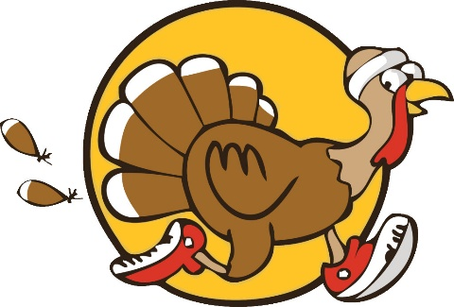
Glyndon Community Association
2024 Turkey Trot Registration

Join us Thanksgiving morning, Thursday November 28, 2024, at 8 am for Historic Glyndon’s first annual Turkey Trot! The race will begin and end at Glyndon Station Park at 41 Railroad Avenue in Historic Glyndon.

Register online at Glyndonca.com and either mail a check and this registration form or scan the QR code to pay the $20.00 registration fee and include your name and contact email. Registrations made after November 20th will not have at- shirt for race day, but can pick theirs up at a later date.


Please also let us know what size shirt you will need. A map of the race day course will be available to view on our website along with parking instructions and arrival directions.
Checks can be made payable to: GCA
Mail to: 2 Railroad Avenue
PO box 86
Glyndon MD 21071

Participants Name: ___________________________________
Address: ___________________________________________
Phone number: ______________________________________
Email address: ______________________________________

